 | June 2017
Sun | Mon | Tue | Wed | Thu | Fri | Sat
Come early and get your ticket for the event! |  |  |  | 1 | 2 | 3
4 | 5  Fantastic Dynamite  Magic Show!  10:00- 10:45  All ages ! | 6  Aladin and His Lamp  Puppet Show  10:00-10:30  2:00-2:30 | 7  More Magic  at the Library!  10:30-11:15  All ages! | 8  Petting Zoo  9:30-11:00  Library Lawn  Popsicles afterwards ! | 9  BINGO FUN!  10:00-10:30  2:00-2:30  LIMIT 30 | 10
11 | 12  Snakes and  Other Creatures  10:00-10:45 | 13  Open House Art  10:00-11:00  All ages! | 14  Juggling Fun!  10:30-11:15 | 15  Sock Rockerz  Exercise Show!  10:00-10:45  ALL AGES! | 16  BINGO FUN!  10:00-10:30  2:00-2:30  LIMIT 30 | 17
18 | 19  McClellans Creature  Open House  10:00-11:00 | 20  Sleeping Beauty  Puppet House  10:00 – 10:30  2:00-2:30 | 21  “Crazy Messy  Art Fun!”  LIMIT 30  Ages 6-10 | 22  Come meet  Smokey the Bear!  Ages 4-7 Limit 20  10:00-10:30 | 23  BINGO FUN!  10:00-10:30  2:00-2:30  LIMIT 30 | 24
25 | 26  Be at Your BEST  Drum Show!  10:00-10:45  WOW! Great! | 27  Open House Art  RED WHITE BLUE!  10:00-11:00  All ages! | 28 Picasso Series  Scribble Scribble Splash Splash Art and Drawing  9:30-12:00  With Artist Karen Weir  Ages 13-18 Limit 12 | 29 Picasso Series  Pottery Creation  Face Vases  9:30-12:00  With Artist Jo Taylor  Ages 13-18 Limit 14 | 30  BINGO FUN!  10:00-10:30  2:00-2:30  LIMIT 30
Welcome to “Sensational Selma Summer 2017!”
Groups MUST CALL and reserve seats. 20 seats per event! 874 -1730!
Don’t miss the Picasso Series! Meet a real artist and make a masterpiece!

 | July 2017
Sun | Mon | Tue | Wed | Thu | Fri | Sat
 |  |  |  |  |  | 1
2 | 3  Library Closed!  Have a great  Holiday! | 4  Library Closed!  Have a great  Holiday! | 5  Come Make Your Own Ice Cream! Limit 15  Ages 8-12  10:00-10:45 | Pasta Art  10:00-10:45 2:00-2;45  Ages 5 up Limit 24 | 7  LAST BINGO FUN!  10:00-10:30 | 8
9 | 10 Picasso Series  Rhythm and Roll  10:00-12:00  With Charles Tortorici  Ages 9-12 Limit 20 | 11 Picasso Series  “Vibrant Animals’  1:00-5:00  Artist Kellie Newsome  Ages 14-18 Limit 12 | 12 Picasso Series  Drama and Theater Fun  10:00-12:00  With Jody Tartt  Ages 14-18 Limit 20 | 13 Picasso Series  Silk Screening Art  10:00-12:00  With Artist Jamie Adams  Ages 14-18 Limit 15 | 14 Picasso Series  “Community Drum Jam”  Led by John Scalici  10:00-10;45  All Ages!! Limit 40  LAST EVENT!!! | 15
16  Have a great year at school and keep reading and learning! | 17 | 18 | 19 | 20 | 21 | 22
23 | 24 | 25 | 26 | 27 | 28 | 29
30 | 31 | All first graders are invited to come and get their own library cards  before starting school!
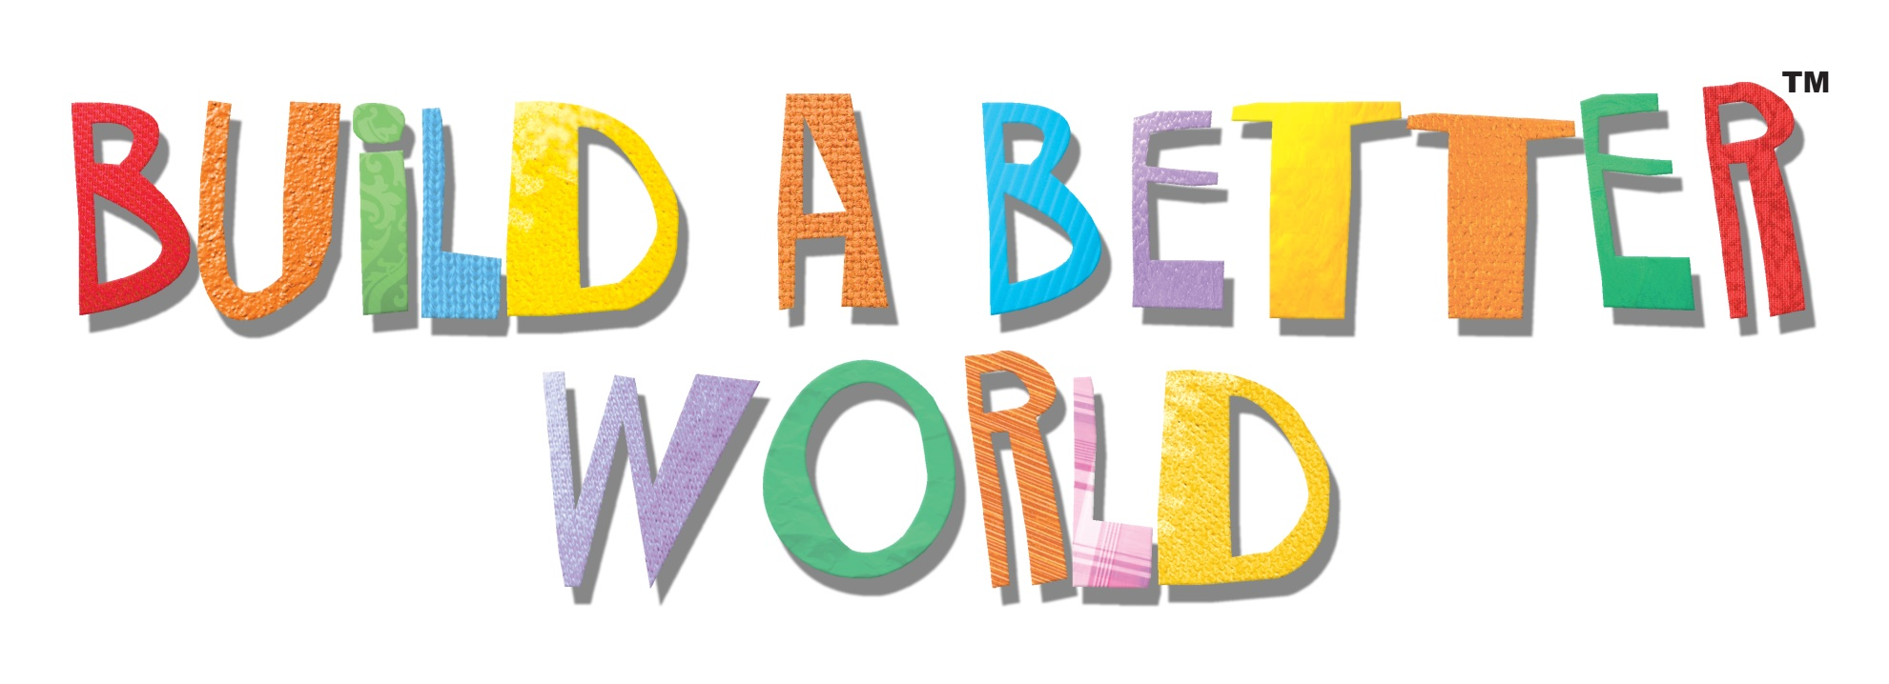

Join us for our Sensational Selma Summer reading program and help us Build a Better World together! Add your ideas and suggestions to the Better World Box in the Children’s Department. 10 ideas will be picked at the end of the summer and winners will be announced before school starts!

Let’s Build a Better World Together!
www.selmalibrary.org

